**DIFFERENT METHODS TO GET UNIQUE VALUES FROM A LIST:**

Using set () method:

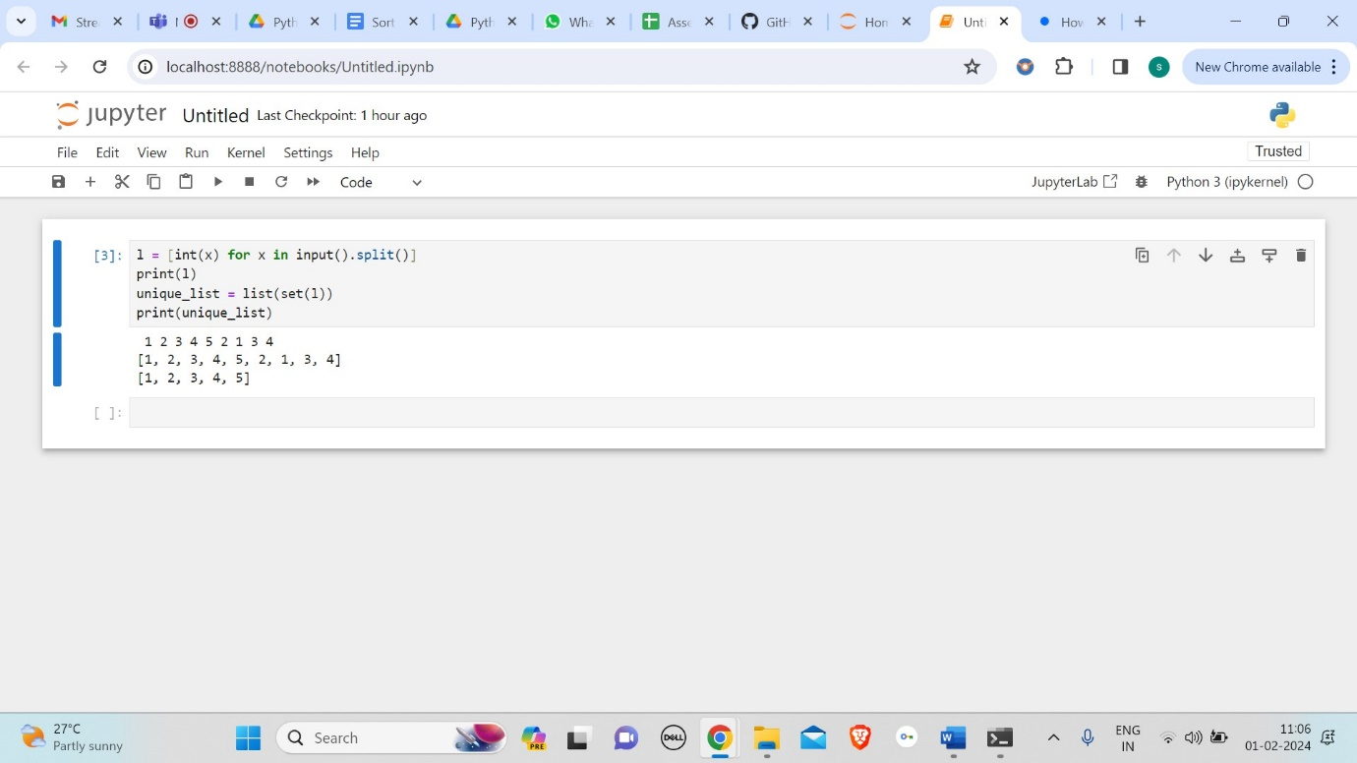

Using reduce () method:

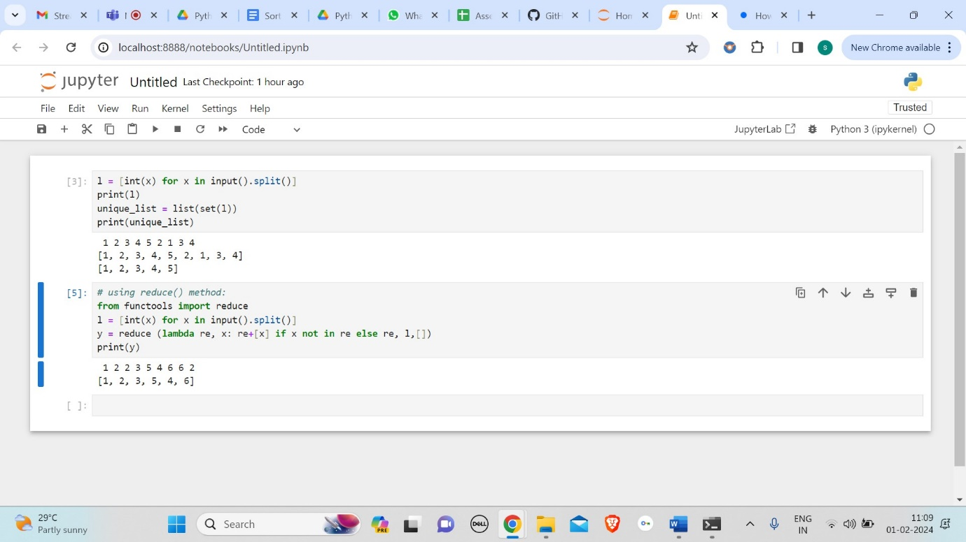

Using operator. countOf () method:

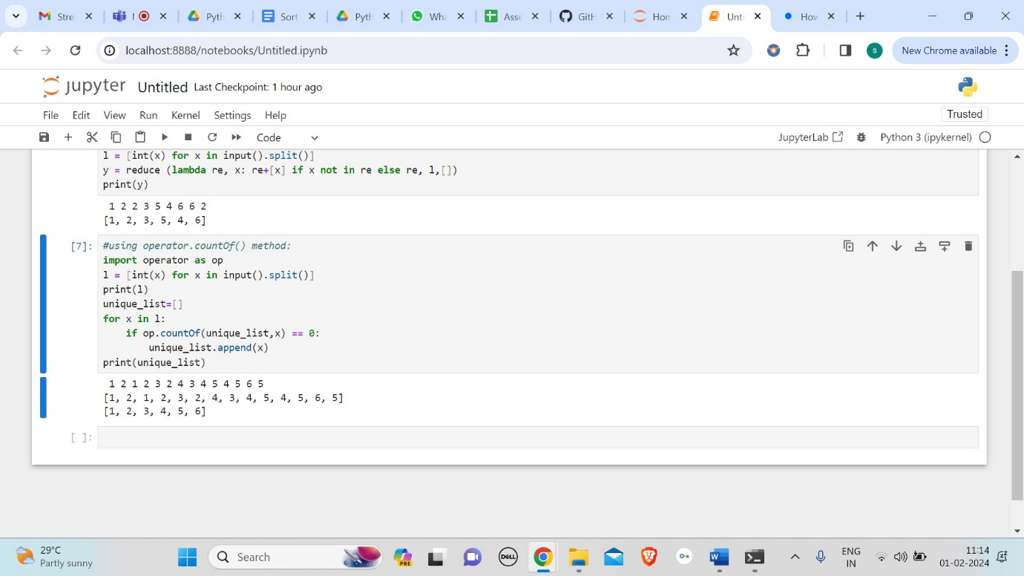

Using pandas module:

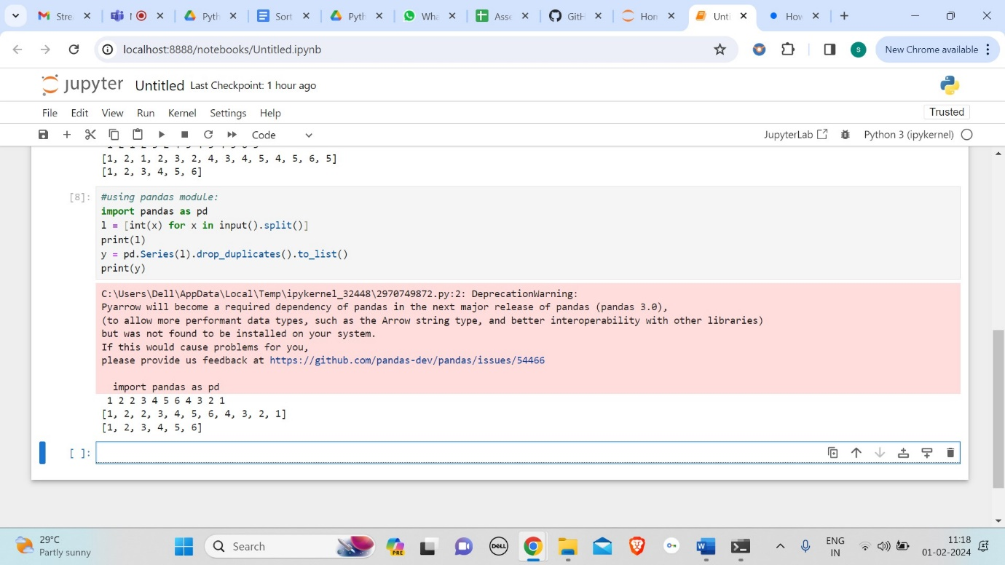

Using numpy.Unique method :

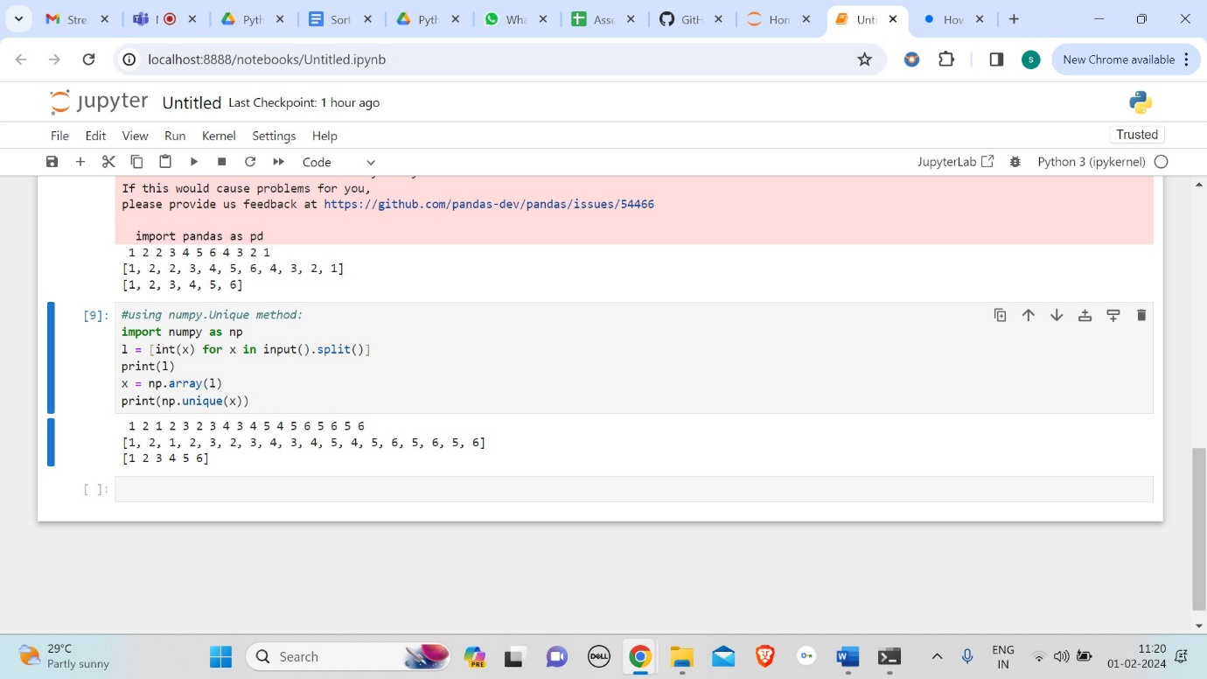

Using collections. Counter () method:

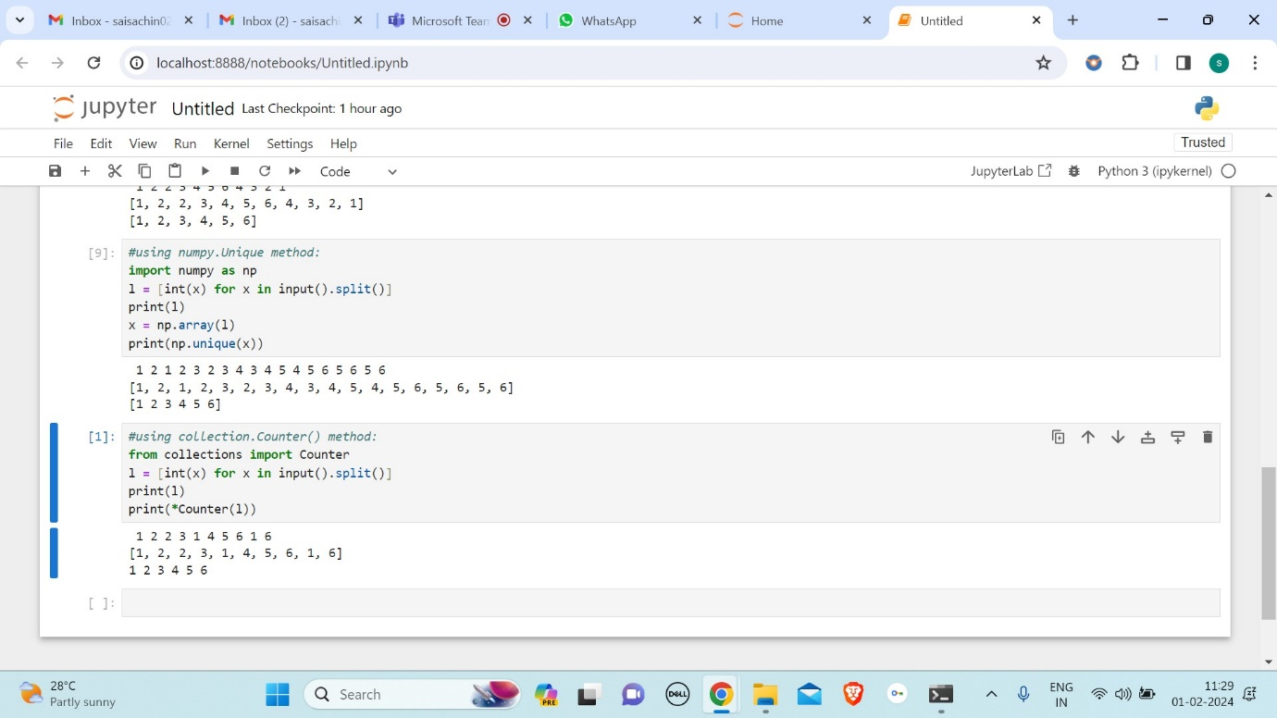

Using dict. Fromkeys ():

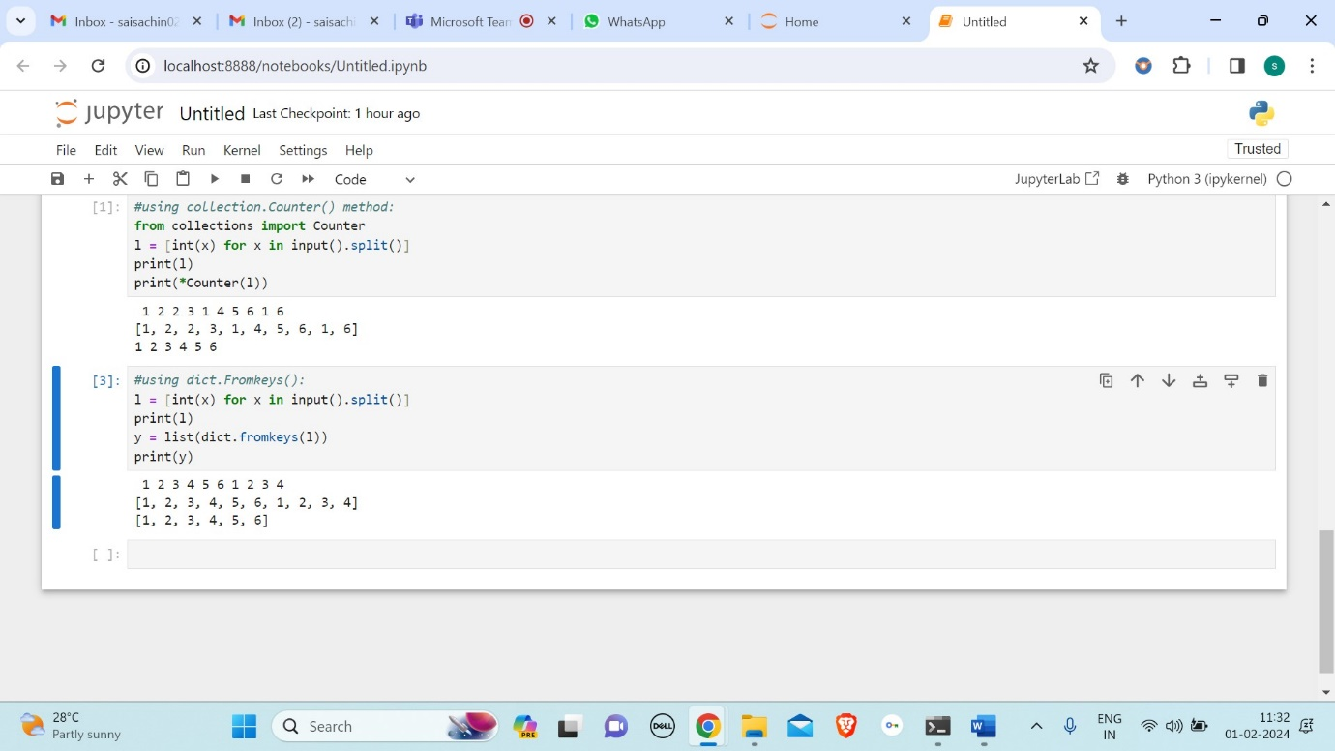

**SORT PYTHON LISTS:**

Using sorted ():

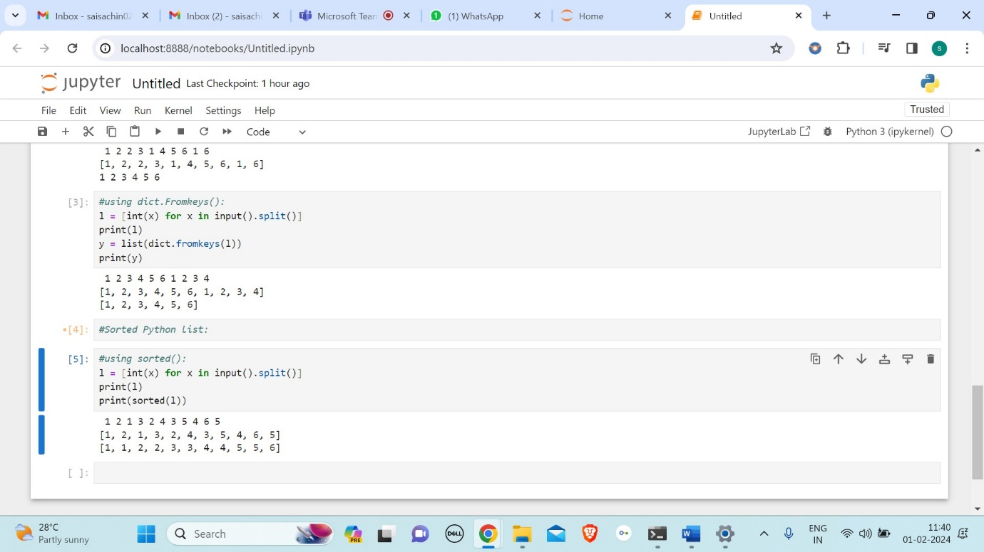

Using sorted () with reverse argument:

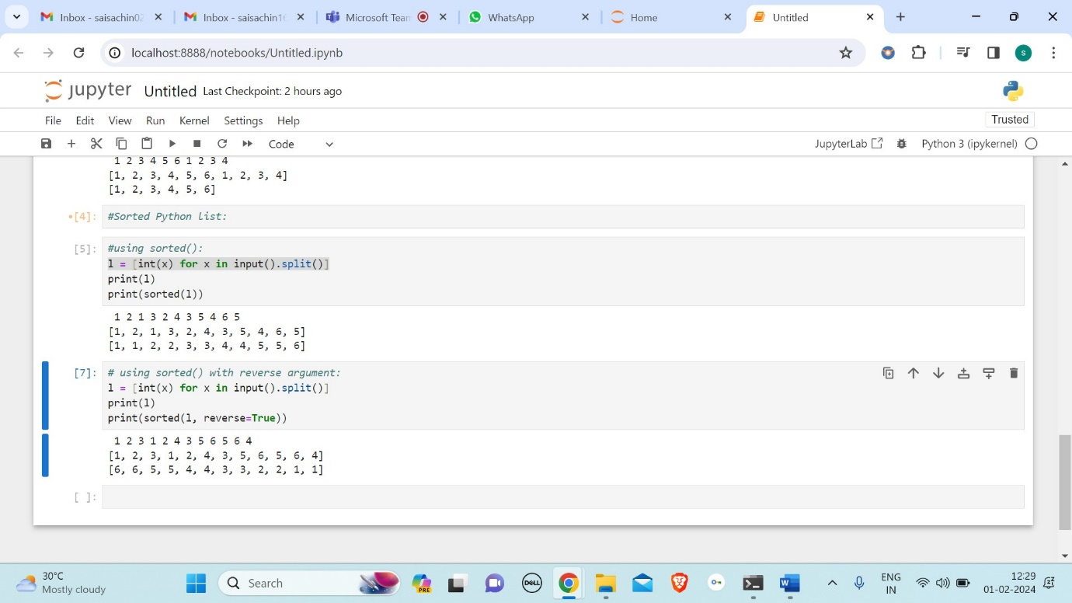

Using sorted () with key argument:

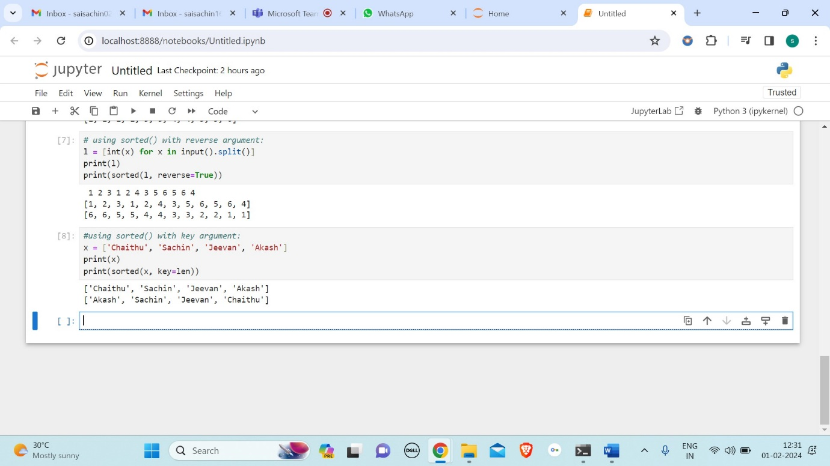

**JSON:**

* JSON stands for JavaScript Object Notation.
* It is a format for structuring data.
* This format is used by different web applications to communicate with each other.
* The official media type for the JSON is application/json and to save those files .json extension.

**CONVERT JSON STRING TO PYTHON DICTIONARY:**

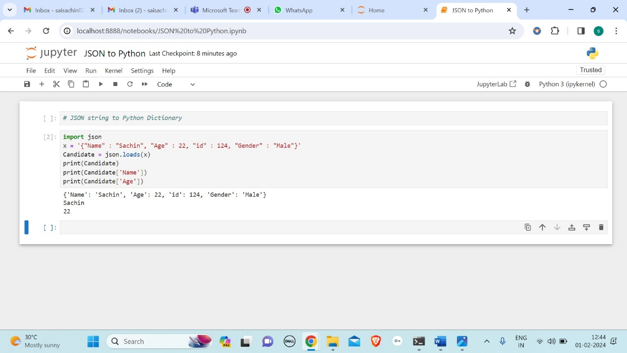

**CONVERT A JSON DATA INSIDE A FILE INTO PYTHON DICTIONARY:**

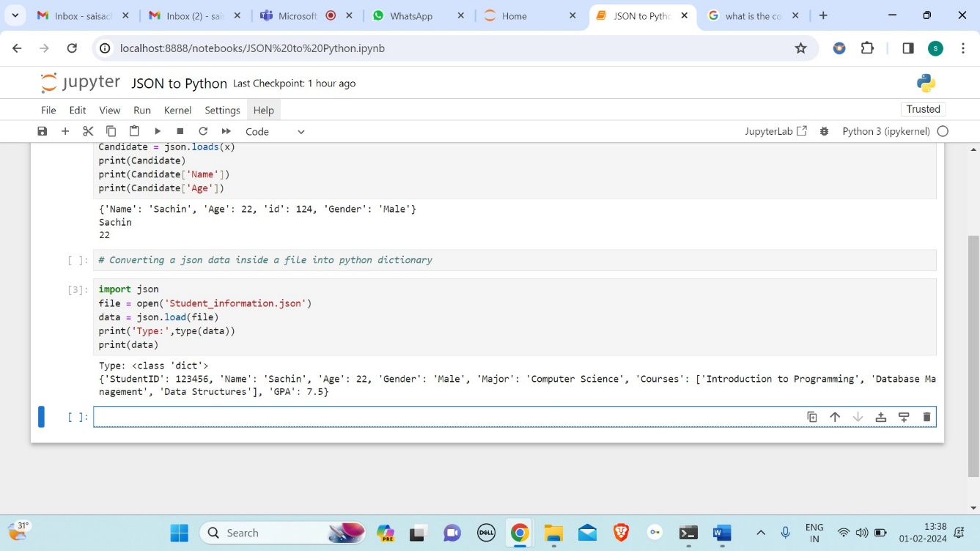

Here the json data is taken from Student_information. json file. And below is the Student_infromation. json file.

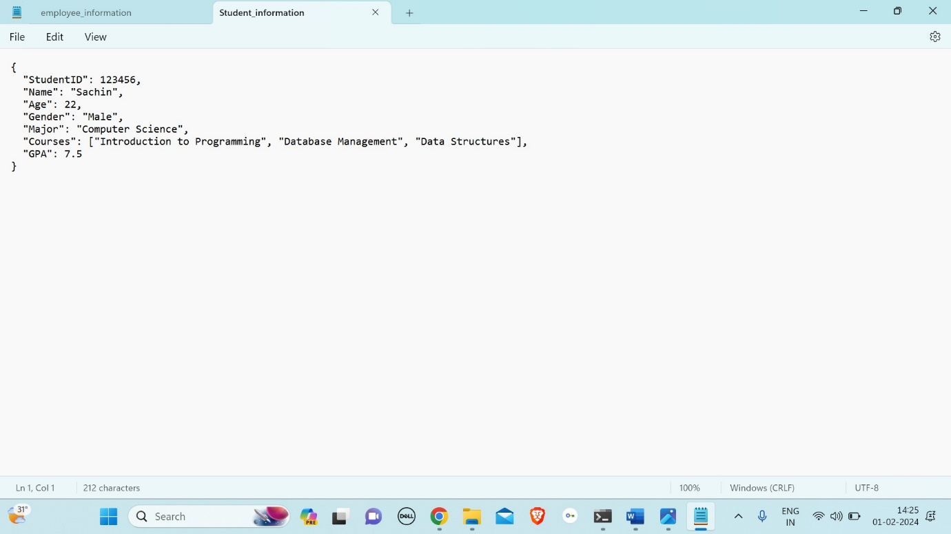

**CONVERT PYTHON DICTIONARY TO JSON:**

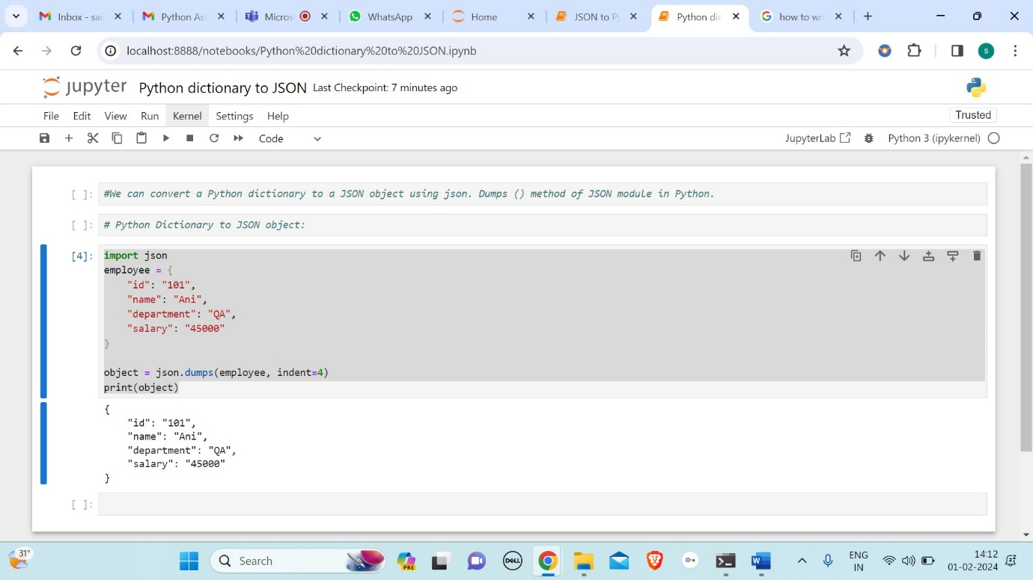

**WRITING JSON TO A FILE IN PYTHON:**

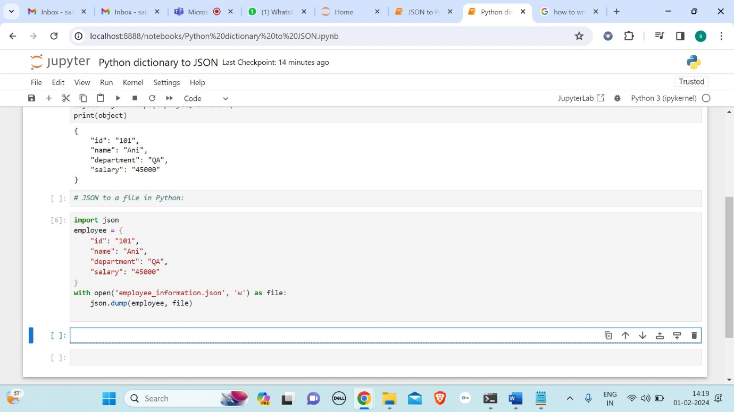

And below is the created file name as employee_information.json.

